Report

Methods:

This project began with a working file, from there it was tested using a variety of parameters. Modifying the number of machines, simulation time, the delta parameter, initial cars, car spacing, seed, and wash time were looked at. From the program, it became clear that some parameters would provide more insight than others, and some only changed the end result slightly.

After looking through the code, the most important factor to consider was the number of machines necessary to keep a line steady or move the line through. The code was modified so that each successful simulation will store an image with the parameters used within the same folder. Beyond that, the simulation of peak times, changes throughout the simulation, and a balking mechanism were also looked at, though they will have a writeup as part of the ‘something different’ section.

Results:

Two random seeds were necessary to directly compare inputs and modifying the parameters of length and initial cars helps provide the graph necessary to find the general trend for machines. Below, there was a 20-minute simulation window which gives a visual representation of the important results. There are a number of different ways to view the simulation but providing an elevated initial car length allows the graph to show the difference between a close car wash time length and an effective car wash time length. The specific parameters used below were -r-56_-m-4_-w-5_-t-3_-s-20_c-6_d-2, while the second graph contains the same parameters with a random seed of 7

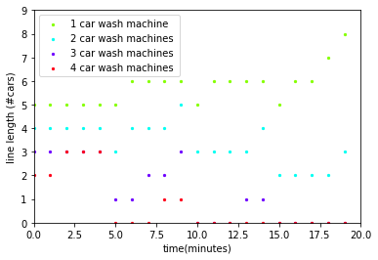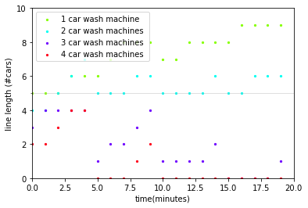

The delta parameter was kept high to elevate the amount of randomness provided. The longer the ratio of simulation time to time interval, the less the delta value will matter, but it does provide some necessary randomness to the simulation.

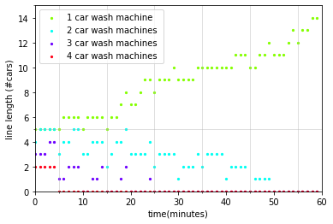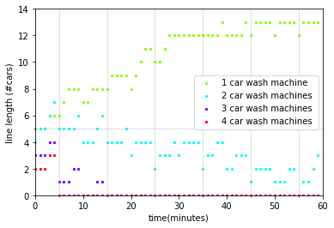

Increasing the length of the simulation shows the eventual progression of two machines, which is necessary for a proper discussion.

Discussion

The primary goal of finding the best number of machines to use depends on two main factors, the number of time interval of customers and the wash time. With a straight simulation with no delta, it is a simple matter of keeping wash time/machine number > time interval. If that ratio is not larger, the line will continually increase until the end of the simulation. This happens at 1 machine in the above graph, the ratio is 2.5:3 for two machines, and it dips in seed 56, and rises in seed 7. Beyond two, the machines can handle the workload before the simulation ends. The longer simulations show the eventual decline using two machines. This helps with the decision on the cost effectiveness of another machine by visualizing the length of time necessary for the ratio to level out given this initial input.

Something Else Methods

Beyond the initial simulation, I made plots containing multiple Poisson distributions and merged this with the original file. The Poisson distribution will create a much closer simulation to a life-like scenario. While the actual numbers are not provided, one or multiple peaks can be viewed and shown. Since this is just a simulation, a simplistic design was used, and the Poisson peaks are distributed evenly throughout the simulation time. To create the peak, instead of using a time-varied car ratio, the total number of generated cars is predetermined before the distribution is calculated. These simulations generally used between one and at most three distributions. It is programmed to handle more, but beyond three distributions would only be useful for extremely long simulation times. In the analysis, simulation times were picked to find the distribution and role of customers vs. machines.

A balking feature was also added to the program, forcing customers to leave with a high line number. A negative input could also be used to ignore the feature and just use the distribution as a program. With the balking feature was added two graphs, one showing the number of customers who balked and the total number of customers unattended (1- simulation time + balking customers), one could call these ‘angry customers.’

Results:

The Balking Feature helped show a little of the issue with 2 machines, but mostly how poor one machine performed. The distribution did bunch people and this led to losses across the simulation time, the delay in line length is from the carwashes filling up. Also there was an error with creating the distributions, they were additive with individual distributions and this led to peaks at the harmonics of distributions. The car distribution was at (arrival time, number cars): [(1, 1), (4, 1), (5, 1), (6, 2), (7, 1), (8, 2), (9, 2), (10, 2), (11, 1), (12, 2), (13, 1), (14, 1), (15, 2), (19, 1)] for seed 56

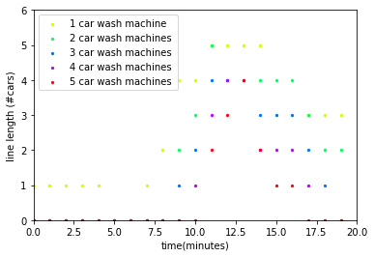 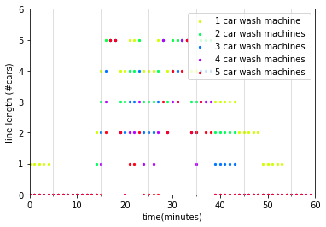

-r-56 -m-5 -w-5 -t-3 -s-20 c-2 d-1 p-2 n-20 b-4, and -r-56 -m-5 -w-5 -t-3 -s-60 c-2 d-1 p-4 n-60 b-4

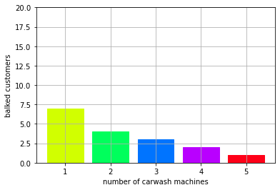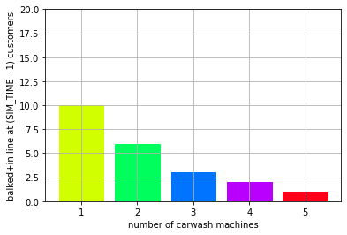

-r-56 -m-5 -w-5 -t-3 -s-20 c-2 d-1 p-2 n-20 b-4 customer issues

Discussion

With the same distribution and the small simulation time, there will be bunches of people in two groups (one for each peak), and the number of machines allows for one extra customer per group. The distribution helps create a more natural simulation, but it does not change the primary ratio. Because the people are bunched up later, this shortens the amount of time for machines to wash cars. Basically, the ratio is still the same, but the simulation time for machines to work on the car line is effectively reduced before reaching max capacity.

So, from this simulation, it would be possible to find the best number of machines to have. For a recommendation, I would choose one or two more than a linear ratio, so one can be repaired at any given time without a large loss in customers. The baseline machine number depends on the desired timeline of completing a certain line of customers. With 8 hours of work, if a 60-minute line can be reduced in about an hour and balking is not a drastic issue, two machines is a good baseline, with one extra as backup. If balking is an issue, 3 machines are recommended to start with, and each machine after will avoid

If the single customer balking issue is worth the machine cost, then the original baseline argument should be very satisfied and more research into actual balking numbers is worthwhile.